- EMAIL [Lead Capture Apps]
SUBJECT LINE: Get it while it’s hot…

BANNER LINE: The faster, the better.

[Loan Officer],

When it comes to getting lead contact information, there’s no time like immediately! Whether you’re at an open house, holding a home buyers’ workshop or pique the interest of a homeowner on social media, Lead Capture Apps are an easy, modern way to move interested parties into your database…and hopefully your pipeline!

Choose Lead Capture Apps from your dashboard menu. Next, click “Create,” and the pulldown menu next to “Layout.” You’ll have your choice of several formats for different lead types.

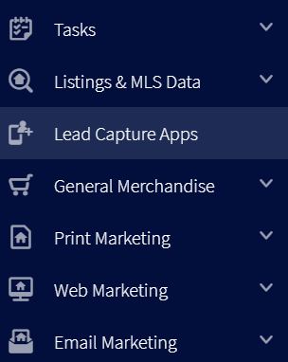
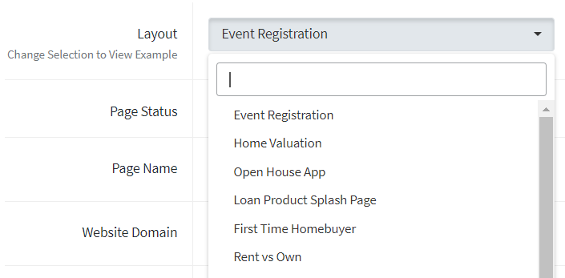
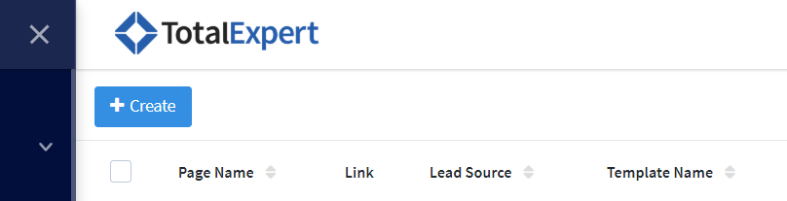

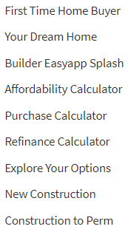
Once you’ve selected your format, enter the title you’d like on your form and fill out the other fields.

Once created, you can create an icon for your phone or tablet and access your newly-created Lead Capture App from your device’s home page.

Get started here!

Questions? Let us know!

