- EMAIL [Support Button]
SUBJECT LINE: Click for help

BANNER LINE: Help is on the way...

[Loan Officer],

Not sure how everything works in our marketing platform? No problem!

Just click the support button in the lower right-hand corner of your screen when you're in the system…

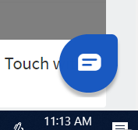

…and help arrives!

Quick questions come up a lot - and you can get quick answers! In addition to ongoing training (check the calendar in the platform), live chat is available from 8:00 AM to 7:00 PM Monday through Friday! You can even get assistance on Saturdays!

[Signature block – customer company/marketing admin?]

