- EMAIL [Ease of log-in/use]
SUBJECT LINE: Take vs. Save

BANNER LINE: Timesaving vs. Time-consuming

[Loan Officer],

It's typical to be skeptical about new systems and tools and wonder, "How much time will it take to get up to speed?"

Our new Marketing Operating System is all about time - not what it takes, but what it SAVES. The Daily Digest comes straight to your inbox and lets you know what marketing is going out, where you need to be and who to call…

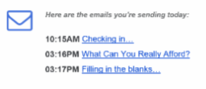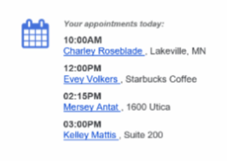
Take a minute to save a ton of time – and grow your business! [link to their user account]

[Signature block – customer company/marketing admin?]

