- EMAIL [Daily Digest]
SUBJECT LINE: Would you like to…

BANNER LINE: Be a pleasant surprise.

Delight partners, past clients and contacts with a birthday call? Congratulations on a home or closing anniversary? You can.

Daily Digest makes it easy by notifying you of important dates - and people to reach out to - straight to your inbox:

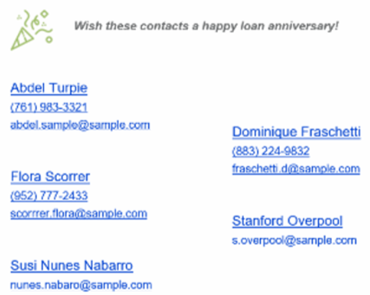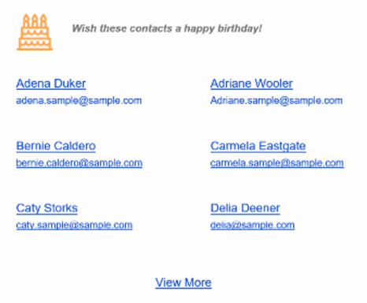
Let Daily Digest get you on track to score points with everyone from prospects to partners!
[Hyperlink to take MLO to Digest Settings]
[Signature block – customer company/marketing admin?]

