- EMAIL [Ensuring Campaigns are Turned On]
SUBJECT LINE: Is this thing on?

BANNER LINE: Less effort, more done.

[Loan Officer],

Are you communicating regularly - and automatically - with all of your leads, partners, contacts and past clients? Here's how to check:

Log in to [the Total Expert system/their name for it]
Click "Journeys" in the Menu bar on the left
Choose "Active Journeys"

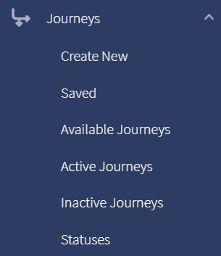

There you'll be able to see if you have Journeys turned on - and how many. Don't miss an opportunity to reap the rewards of consistent, relevant, effortless communication!

Questions? Let us know.
[Signature block – customer company/marketing admin?]

