- EMAIL [Email Stats]
SUBJECT LINE: Performance review…

BANNER LINE: What’s really going on?

[Loan Officer],

Who's receiving, opening, clicking and unsubscribing to your emails? It's easy to check.

Go to Email Marketing in your user account and select Email Stats. There, you'll find detailed information on how your campaigns and outreach are performing:

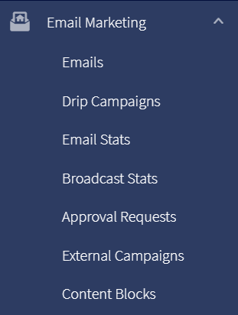

Monitor how your contacts are engaging with content so you can stay on track to reach your goals and win in your marketplace! Learn more here.

[Signature block – customer company/marketing admin?]

