- EMAIL [Sending personalized videos]
SUBJECT LINE: It's the BOMB…

BANNER LINE: Be personable.

[Loan Officer],

Reaching out to contacts - in person - is challenging but extremely effective. A quick video message is a great way you can make "one to many" contact that still feels personal, and you can send them quickly, easily and often using the BombBomb integration.

Make sure you have a BombBomb account and connect it to your user account. Go to the dropdown under your username and click Integration Settings:

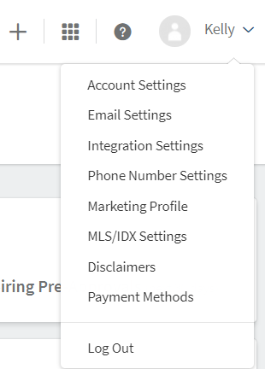
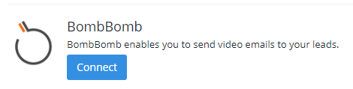

Click to connect and you'll be asked for an API Key. You'll get this by following the same process of clicking Integrations under your username in your BombBomb account and selecting our platform name. Your API Key will show up on the upper right side of the page:

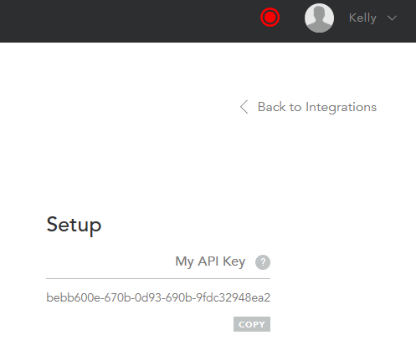
Copy the API Key and paste it in the box provided on our platform page. Now you're ready to record and send a message that's timely, relevant and full of (your) personality!

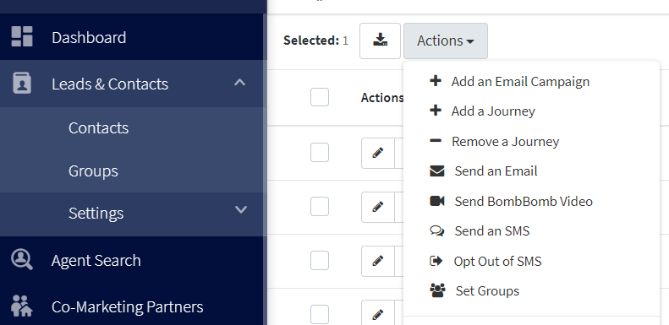

[Signature block – customer company/marketing admin?]

